ORAL RABIES VACCINATION AREA
NOTICE

The Wildlife Services (WS) program of the U.S. Department of Agriculture’s Animal and Plant Health Inspection Service (APHIS) is working with the Alabama Department of Public Health to protect people and pets from the threat of rabies in your area. WS is distributing an oral rabies vaccination (ORV) bait to vaccinate raccoons, foxes, and coyotes and help stop further spread of rabies. ORV baits are about the size of a matchbox and are coated with fishmeal flavoring. ORV baits can be distributed by airplane, helicopter, or car.

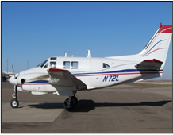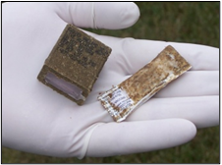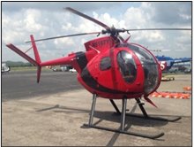

ORV Baits will be distributed between: January 20 – January 30, 2023

What if I find rabies baits?
If you find ORV baits, leave them alone, unless they are where children or pets play. To move ORV baits safely, you should:
- Wear gloves or use a paper towel or plastic bag when picking up the baits.
- Toss intact baits into a wooded area or other raccoon habitat.
- Bag and dispose of any damaged baits in the trash.
- Take precautions by practicing proper hygiene – wash with soap and water any skin or wounds that may have come into contact with ORV baits, especially if the bait was damaged.

What if my pet eats the bait?
- Don’t panic! A few baits are not harmful, though eating a large number may cause an upset stomach.
- Do not risk getting bitten or being exposed to the vaccine by taking a bait away from your pet.
- Check the area for more baits and relocate any remaining baits to a wooded area.
- If your pet eats a bait, avoid your pet’s saliva for 24 hours, and wash skin or wounds that may have been licked.

Questions about ORV or bait you have found?
- Call the Rabies Information Line at: 1-866-4-USDA-WS (1-866-487-3297)
- Call the Alabama Dept of Public Health at: 1-800-ALA-1818 (1-800-151-1818)

